

**Our full privacy notice can be found on our website https://www.seatonandcolytonmedicalpractice.nhs.uk/**

**[INSERT link]**

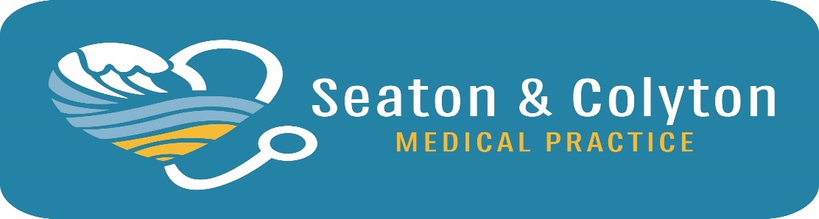

We may also tell your parents/carers what personal information we have about you, how we keep it safe, what we use it for and with whom we share it.

Sometimes we have to share your information with other people we know who help us look after you or to keep you safe (like your Social Worker or a Doctor at the Hospital).

We make sure we keep your information very safe and follow special Data Protection laws to make sure nobody can see or use your personal information.

**We do this so we can:**

* Keep you safe
* Help keep you healthy
* Share information with other organisations involved in your care (like the Hospital)
* Keep you and your parents/carers updated about how your care is progressing.

**This leaflet explains what happens to the information that Seaton and Colyton Medical Practice collects about you whenever you visit us or when we talk to you or someone about you on the phone. It also describes how we make sure your information is kept safe.**

Information is sometimes called data and keeping personal information safe is called **Data Protection**. If you would like to discuss your rights on how we use your data, you can contact your practice.

**We collect information about you such as:**

* Your name
* Why you are coming to see us
* Your birthday and year you were born
* Your address
* The name of the person who will generally bring you to your appointments
* Any information that you or your family gives us
* What we do to care for you